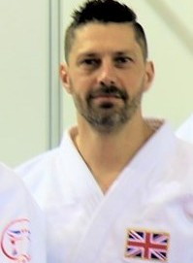

**Safeguarding & Protecting Children Course**

**&**

# Emergency Sports First Aid Course

**Venue: Gendros Judo Club. Swansea SA5 8JF**

# Sunday 15th, September 2024

**Safeguarding - Course Fee £35 0930 to 1245**

**First Aid - Course Fee £55 1315 to 1630**

**Course Tutor: Lee Holley 5th Dan**

**These sessions are suitable for those needing to complete the face to face course requirements for new BJA coach awards or revalidation of existing awards.**

**To book a place on the training, please email Kate Woolven on** [**firstaidswimtraining@gmail.com**](mailto:firstaidswimtraining@gmail.com)

**Please identify which course you are attending**

**Places are limited to 12 per session**