# Logo, company name Description automatically generatedBritish Judo Association Election 2021

President

Nomination Form

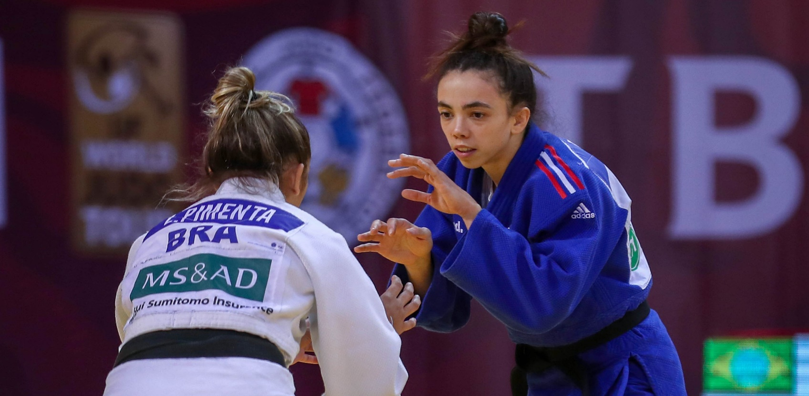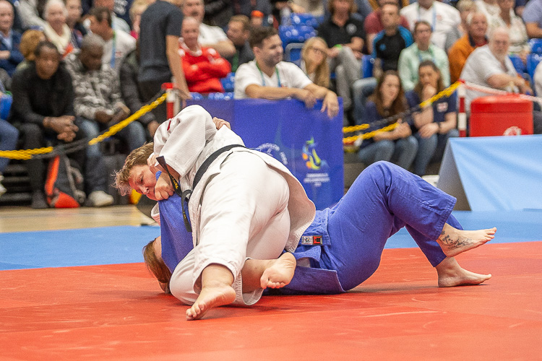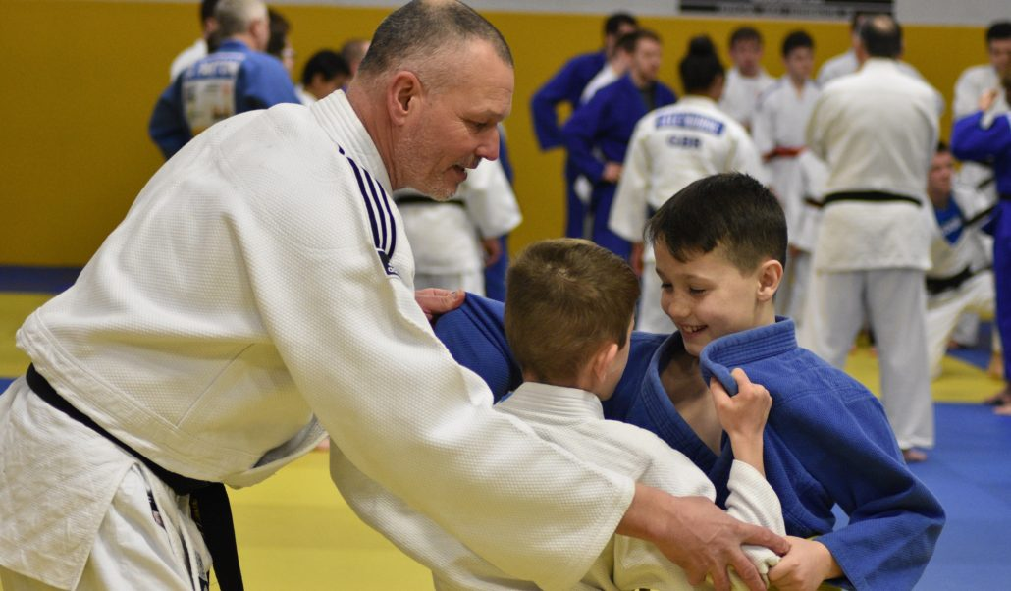

**YOUR DETAILS**

Title: Mr

Surname:

Mrs

Miss

Ms

Other (please state):

Forename(s):

Home address, including postcode:

Home tel:

Email:

Association License Number, if you have one:

Mobile tel:

Date of Birth:

/

/



**YOUR SUPPORTERS**

You need 5 clubs who agree to support your application. Please provide their details below:

Club Name &No

Supporter’s name:

BJA Licence No:

Supporter’s signature:

Club Name & No

Supporter’s name:

BJA Licence No:

Supporter’s signature:

Club Name & No

Supporter’s name:

BJA Licence No:

Supporter’s signature:

Club Name & No Supporter’s name:

BJA Licence No:

Supporter’s signature:

Club Name & No

Supporter’s name:

BJA Licence No:

Supporter’s signature:

Please upload a digital head and shoulders photograph of yourself over the top of the box on the right.

If you are not able to do this, please email your photo along with your completed nomination form to bja@ukengage.org

**What experience and skills do you feel you would bring to the role?**

**Why should members vote for you? (maximum 100 words)**

**700 WORD CANDIDATE STATEMENT**

You can only write a maximum of **700** words in total. If you write more than **700** words the extra words will not be sent to people to read. We will copy what you write exactly how it is written which means that you need to be careful not to make any mistakes.

Please answer the questions below by writing under each question in the space below.

You must not use more than **100** of your **700** words to answer the ﬁrst question.

**Referring directly to the Person Specification, please describe how you meet the criteria for the role?**

**What experience and skills do you feel you would bring to the role?**

Total no. words for

questions 1 -3 (max 700:

Page 3 of 4

**THE ROLE OF THE PRESIDENT**

## THE ROLE OF DIRECTORS

The role of the President is primarily to act as an ambassador for the sport of Judo and to represent the British Judo

Association by attending, when required, World and European events.

The President shall hold office for a period of five (5) years, or such other period as the Association may determine. The

President shall act as Chair of the Annual General Meeting and of meetings of the Council.

You will also find our Equality Statement at: <https://www.britishjudo.org.uk/the-british-judo-association/governance/policies-and-guidelines/equality-statement/>

By signing this nomination form you acknowledge you have read and agree with our Equality Statement

## CODE OF PRACTICE

### The British Judo Association expects its staff and Board Members to recognise and avoid activities or investments which involve, or might appear to involve a conﬂict of interest. All employees President and Board Members shall be expected to observe the guidelines and declare any potential conflicts of interest.

**Potential Conflicts:**

Potential conﬂicts may occur in a number of different forms:

* Where an individual is in a position to receive a direct ﬁnancial gain from their involvement in the Association
* Where an individual is in a position to receive an indirect ﬁnancial gain from their involvement in the Association
* Where an individual is in a position to inﬂuence a commercial contract for any development work funded by the Association
* Where an individual is in a position to inﬂuence the appointment of staff who will work for the Association
* Where an individual is in a position to inﬂuence the accounting process
* Where an individual has membership in, or involvement with, a particular Judo club who may receive support from the Association
* Where an individual has involvement with a particular Judo player who may receive support from the Association
* Where an individual has an involvement with any other potential partner of the Association (be it a Local Authority or any other Judo organisation)
* Where the employee of the Association is also employed by another organisation
* Where an employee of the Association is acting for other organisations in a self-employed/professional capacity

**17 m**



**ELIGIBILITY**

Please conﬁrm you are eligible to stand by agreeing to the conditions below:

Signature:

Date:

**Eligibility declarations part 1**

1. I have no receiving order made against me and have not made any arrangement or composition with any of my creditors;
2. I am of sound mind;
3. I am not or have not been suspended from membership of the Association for any reason;
4. I am not a paid official of the Association;
5. I am not prohibited by law from being President.

**Eligibility declarations part 2**

I am not suspended from being a Licence Holder or otherwise have not been suspended from the Association for any reason in the last four (4) year period (such periods commence on the expiry of that person’s suspension from the Association.)

**DEADLINE**

Nominations must be received by

**5.00pm on FRIDAY 17th September 2021**

**September**

* You can also send the completed form via email to

[**bja@uk-engage.org**](mailto:bja@uk-engage.org)

* Or if you prefer you can post the signed, completed form to: British Judo, UK Engage, Image House, 10 Acorn Business Park, Heaton Lane, Stockport SK4 1AS.