**British Blind Sport**

**Youth Advisory Panel**

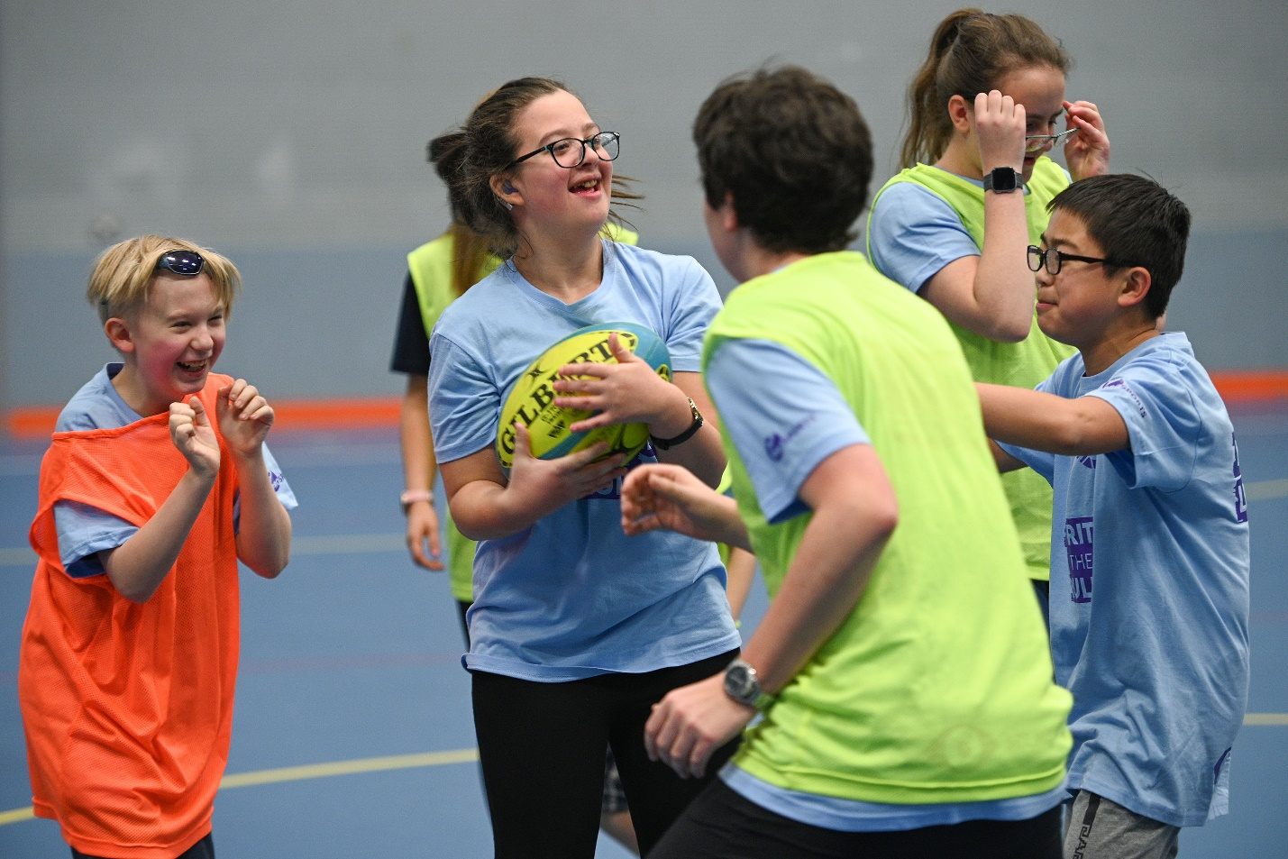

Image shows Sport England logo


# Who are we?

British Blind Sport is the National Disability Sports Organisation (NDSO) responsible for promoting sport and physical activity for people with a visual impairment in the UK.

We work with a host of partners, including national governing bodies of sport, clubs and leisure centres, to grow sport and physical activity opportunities for people with a visual impairment. Often underrepresented in the sports sector, it is vital that people with visual impairments are supported and accounted for when trying to become, or remain, active.

# What is the Youth Advisory Panel?

The Youth Advisory Panel is a group of up to 12 young people with a visual impairment, who are passionate about supporting their peers to become active. The panel will act as a voice for other young VI people in the UK, support British Blind Sport with policy and project development and advise on issues relating to young visually impaired people in sport and physical activity. As this project develops we are hoping that the panel will also influence a range of sports organisations on how they can best support visually impaired volunteers and participants.

The panel provides a unique opportunity to work directly with British Blind Sport, our members, partners and funders in order to influence positive change for young visually impaired people.

The panel also offers members the chance to become ambassadors for British Blind Sport and to champion our work from the perspective of young people.

# Who are we looking for?

We are looking for applicants that…

* Are aged between 16 and 25 years old and live in the UK
* Can commit to 4-6 face to face meetings a year (Covid-19 permitting) plus virtual catch up meetings and a couple of hours a month for project work. The frequency of the virtual catch up meetings will be decided by the Panel at the first meeting
* Have a passion for supporting their peers and enacting social change through sport and physical activity
* Enjoy working with others and can effectively communicate with others

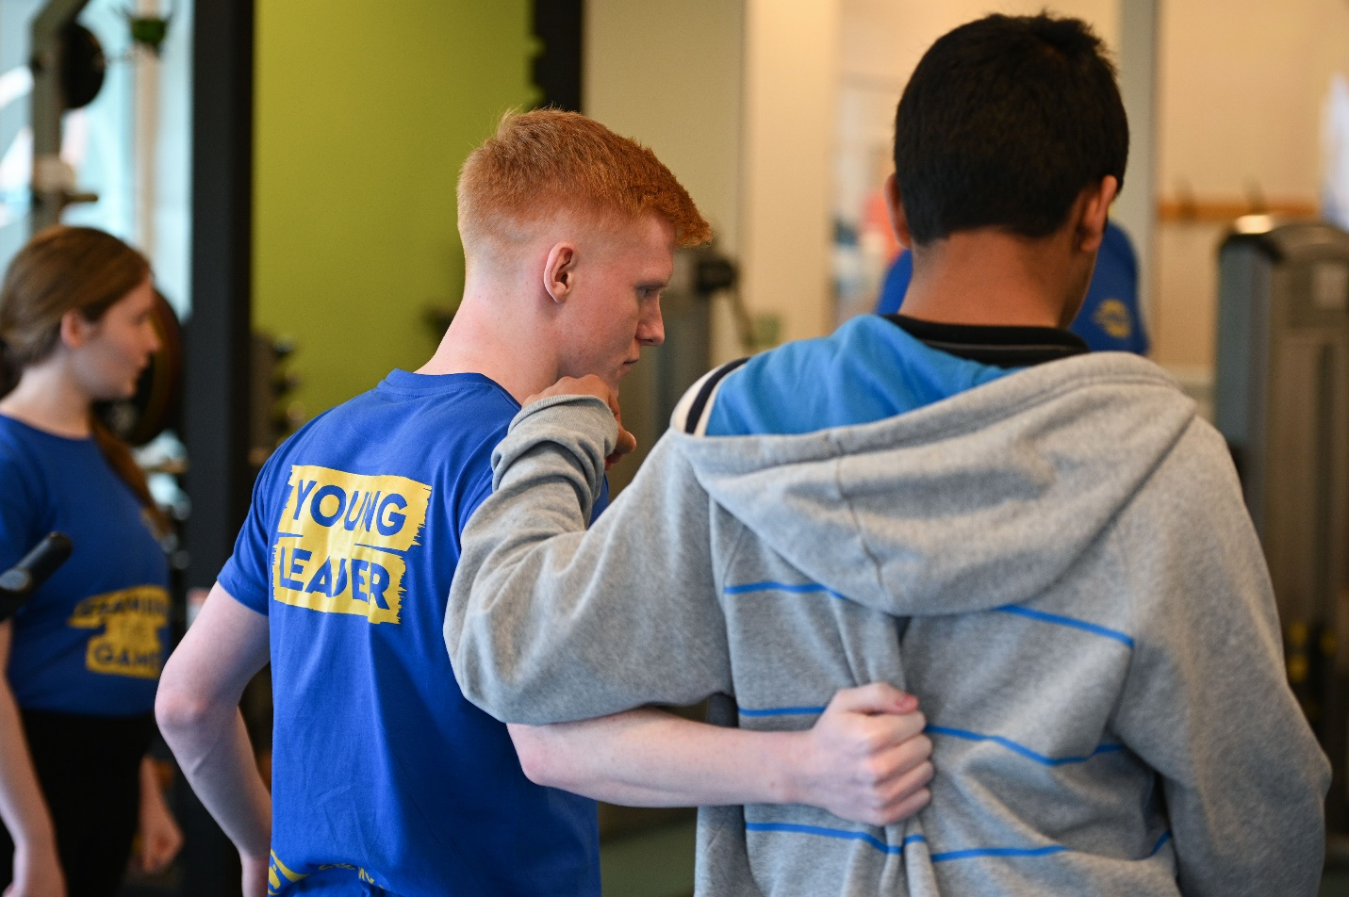

# What you’ll get from us?

* The opportunity to act as a representative of young people with a visual impairments in sport
* Taking part in an ongoing mentor scheme with experts in the sports sector
* The opportunity to network with our members, partners and other stakeholders
* Development of project management and team working skills through meetings and group work
* The chance to work with experienced British Blind Sport staff in areas such as communications, policy and fundraising
* Reimbursement of agreed expenses whilst a member of the panel

# How to get involved

Applications can be submitted in three ways – through a word submission form, by video or by audio recording. If applying by video or audio recording please answer each question on the application form and try not to go over 1 minute for each answer!

The application form can be found on the Youth Advisory Panel webpage, available through this link: [www.bit.ly/BBSYAP](http://www.bit.ly/BBSYAP)

All applications need to be sent to Tommy Garwood, Young Leaders Officer, by 5pm on Friday 16th October. When sending large media files it may be best to use WeTransfer, a free platform that allows you to send up to 2GB of content via email.

Tommy can be contacted using his email – [tommy@britishblindsport.org.uk](mailto:tommy@britishblindsport.org.uk).

After the applications close, we will shortlist applicants to attend a selection day. This selection day will take place on Saturday 7th November, either physically, or virtually through Zoom.

All the key dates that you’ll need for the Youth Advisory Panel are listed below;

Friday 25th September – Applications open

Friday 16th October – Applications close

Friday 30th October – Shortlist confirmed and applicants are invited to the Selection Day

Saturday 7th November – Selection Day

Friday 13th November – Panel members confirmed and notified

Tuesday 24th November – Youth Advisory Panel first meeting