
BRITISH JUDO ASSOCIATION
BRITISH NATIONAL INCLUSION OPEN TRAINING DAY
This is a national training day open to both Senior and Junior Players (including under 8s players)
We would like to welcome all players that have a Physical, Sensory or Intellectual Impairment.
We also look forward to seeing all the GB SN Squad players to the 1st Inclusion Training Session of the year.
Venue: British Judo Centre of Excellence, University of Wolverhampton Walsall Campus, Magdalene Road, Walsall, WS1 38D
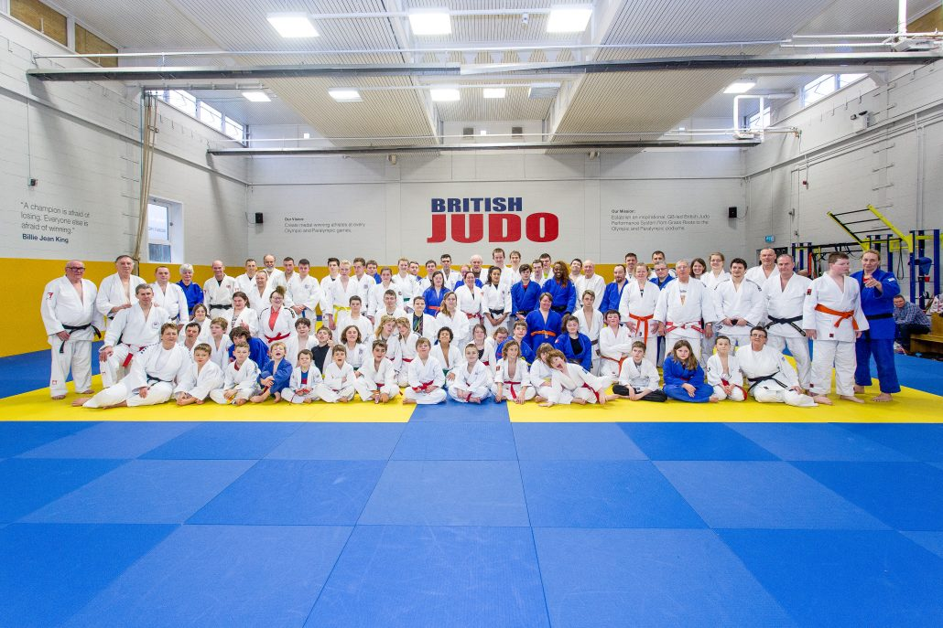
Date: Saturday 10th February 2018
Booking From: 09:00am – 09:45am
Training: 10:00am – 2.30pm (approx.)
Cost: FREE to all attending
Closing Date: Monday 5th February 2018
Please complete entry form below (email copies are acceptable)
For further information, please contact Kerry Tansey, BJA Disability Lead
E-mail: kerry.tansey@britishjudo.org.uk
Mobile: 0796 777 8121
-------------------------------------------------------------------
British Inclusion Training Day
British Judo Centre of Excellence, Saturday 10th February 2018
CONTACT DETAILS
Name of Club ______________________________________
Names of Visually Impaired players, Special Needs Players, Under 8s Children + Contact number.
--------------------------------------------------------------------------------------------------------------------------------------
--------------------------------------------------------------------------------------------------------------------------------------
E-Mail address -----------------------------------------------------------------------------------------------------
Name of Carers/Coaches: --------------------------------------------------------------------------------------------------
Send application to:
Kerry Tansey, British Judo Disability Lead.

7, Speakman Avenue. Newton-le-Willows. WA12 0NW
Inclusion Special Needs Training Day
- We have a fantastic training day ahead, sessions suitably addressed for all our athletes with Disabilities.
- GB squad senior and junior players supporting throughout the day, GB team coaches will be on hand for the training day (subject to change depending on GB duties)
- Senior special needs referee Ron Cleere will be on hand to cover refereeing, Jean Cleere, Andrew Scott both senior championship controllers will be giving advice competition levels and processes.
- Having the services of so many coaches who are expertise in different areas of special needs judo will ensure we have a fantastic training day.
- There will be two mat areas to accommodate different levels of Visually Impaired players and all disabilities we can cater for all. Wheelchair players with their care workers or coaches will enjoy this training day as we are open to all levels of disabilities for junior and senior people wishing to have a fun day’s training with top coaches involved in British inclusion.

Book in 9:00am – 9:45am
Welcome 10am

Divided between two mats:
Mat 1 (levels 3, 4, 5) Mat 2 (levels 1, 2)
10.00 – 12.00 30 to 40 minute workshops 10.00 – 12.00 Newaza and Tachiwaza skills Technical content
15 to 20 minute breaks between workshops

12.00 – 1.00 Lunch 12.00 – 1.00 Lunch
1.00 – 2.30 Team Games/Randori elements 1.00 – 2.30 Randori

Finish 2.30pm
Thank you’s, Rei, pictures.
Tea and Coffee provisions in the Board Room for parents/coaches etc.
By entering the event, all participants and parents or guardians of participants are consenting to photography/filming which may be taken by the BJA or an official BJA contractor at the event. You also accept that these photographs or video may be used in future BJA publications or published by the contractors. If you wish to opt-out of the above please contact communications@britishjudo.org.uk or contact a member of BJA staff at the event.

