**INTRODUCTION**

**British Judo UK SPORT Allocated Places > OLYMPIC – 22 Athletes**

This Policy Statement outlines the background, guiding principles, eligibility and criteria to the British Judo World Class Performance Programme (WCPP) during the TOKYO Cycle – 1 Dec 2017 to 30 Nov 2020.

British Judo has been allocated 22 places by UKSPORT for the Olympic Programme during the Tokyo Cycle (2017 – 2021) to support athletes on the British Judo World Class Performance Programme. Athletes who are identified for the WCPP will receive Coaching, Sports Science Sports Medicine Provision, Programme support and Financial (Athlete Performance Award – APA) support.

* 1. All athletes on the World Class Performance Programme will be based at the British Judo Centre of Excellence in Walsall, the National Training Centre for the British Judo World Class Performance Programme.
  2. There will be three distinct athlete groups that will operate through the Tokyo cycle providing bespoke programmes for each athlete relative to their position in the WCPP:
  + Podium
  + Podium Potential
  + Academy Programme (Full-time > 7 places, Part-time > 7 places)
  1. British Judo can offer up to 22 athlete places on the World Class Performance Programme at any one time and they will receive an Athlete Performance Award (APA) to support their training and competition programme. To note, an APA is not to supplement an income or be relied upon to cover essential living costs.
  2. Athletes will be identified and supported on the programme on an annual basis running from 1st December to 30th November.
  3. Athletes will be reviewed twice a year – a Six Month Review in May and Twelve Month Review in November.
  4. All athletes on the British Judo World Class Performance Programme will be prioritised athletes who will have their own Individual Athlete Plan (IAP) – an annual periodised training and competition programme with agreed goals aligned to British Judo’s Tokyo Strategy and What It Takes To Win (WITTW) model.
  5. On top of their Coaching, Sports Science and Medicine programme and IAP, athletes will also receive financial support at one of five APA levels based on their performance over the previous year, **and equally as important,** their future potential, training behaviours, commitment and attitude.
  6. Podium Potential athletes will also be considered against the progression of their **Trademark Profile (WITTW) plus** their Performance level.

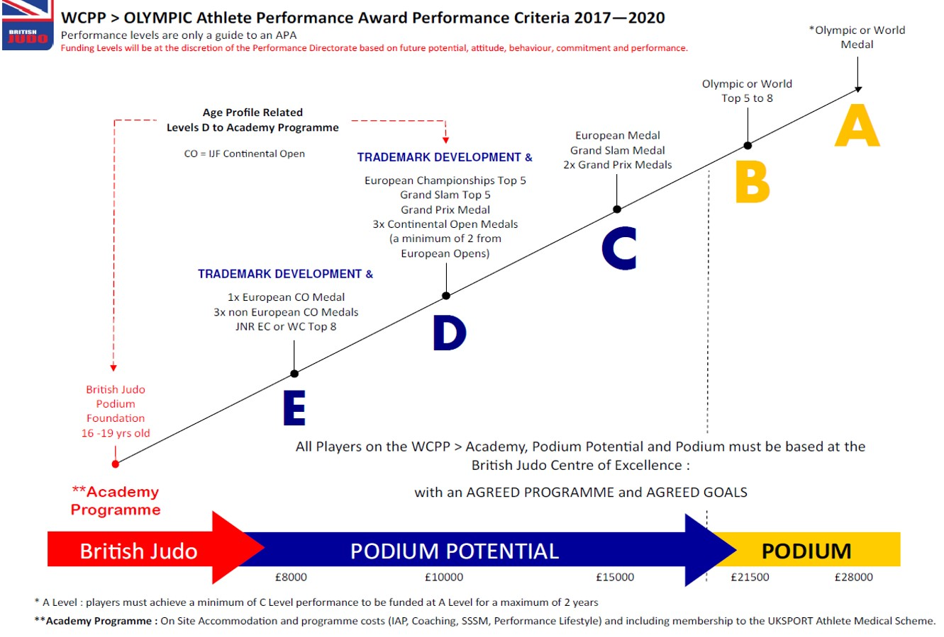**Olympic Programme > Athlete Performance Matrix and Criteria**

* 1. The *APA matrix* is only a **guideline** to determine funding levels and additional factors will determine the level of funding that an athlete receives based upon:
     + their time on the WCPP,
     + their age,
     + progress against Trademark development and WITTW model,
     + future potential,
     + training behaviours,
     + commitment and attitude.

**PODIUM**

* 1. A Podium level athlete is defined as one possessing a genuine and strong medal potential at the Tokyo Olympic Games by qualifying with the WITTW On The Mat Profile. ‘Being the best in Britain, qualifying for a European or World championship team’, would not confer, by right, inclusion of any athlete on to the world class programme at Podium level.
  2. There are two levels of award at Podium Level, A & B and they are determined by achieving performances at our annual Milestone Targeted Event – Senior World Championships and the Tokyo Olympic Games.

|  |  |
| --- | --- |
| A Level | £28,000 per annum |
| B Level | £21,500 per annum |

* 1. Athletes who achieve *‘A level’* performance will be funded at *‘A level’* for up to 2 years, provided that they have achieved a minimum performance level of one of the following:
* World Championship top 8 placing
* European Medal
* Grand Slam Medal
* 2 x Grand Prix Medals
  1. Athletes who achieve B level performance will be funded at B Level for 1 year.

**PODIUM POTENTIAL**

* 1. Podium Potential athletes are identified as athletes who have the potential to qualify for Tokyo and/or qualify and medal at the 2024 Olympic Games with an AGE PROFILE between 17 and 26 years of age. Athletes over the age of 26 years old, must be performing at C Level as a minimum standard and expected to transition to A or B level within 2 years.
  2. Athletes are expected over time, to progress onto Podium level **within 4 – 6 years**.
  3. There are three levels of APA at Podium Potential Level – C, D and E which are determined by the Trademark Profile of the WITTW model, performances at identified events, together with specific conditions as in **1.9:**
     + their time on the WCPP,
     + their age,
     + progress against Trademark development and WITTW model,
     + future potential,
     + training behaviours,
     + commitment and attitude.

|  |  |  |
| --- | --- | --- |
| C Level | £15,000 per annum | Maximum of 4 years |
| D Level | £10,000 per annum | Maximum of  4 – 5 years **&** **progression against the Trademark Profile** |
| E Level | £8,000 per annum |

**C Level – maximum of 4 years**

* 1. Athletes who wish to be considered for an APA at *‘C Level’,* must have achieved one or more of the following levels of performance:
* European Medal
* Grand Slam Medal
* 2 x Grand Prix Medals
  1. Athletes will be funded at C Level for no longer than 4 years as it is expected that they would have progressed onto Podium Level within this time period.
  2. Athletes who have not progressed beyond *‘C Level’* within 4 years or are 26 years and older, may not be considered for membership to the WCPP if evidence shows that progression has stagnated or there is a decline in performance, commitment or attitude.

**D & E Levels – maximum of 4 – 5 years**

* 1. Athletes must be aged between 17 and 26 years of age and assessed positively against the ‘*Trademark Profile’* to be considered for an APA at *‘D or E level.’*
  2. Athletes will be expected to evidence progression each year against the *Trademarks & WITTW* model in order to be considered for membership to the WCPP. This requirement ensures that Podium Potential athletes are developing against the Trademark Profile to have the technical components to ultimately transition to Podium levels, perform and medal at Milestone Events including the Olympic Games. Other components such as physical progression and mental skills (PCDE’s) will also be taken into consideration.
  3. To be considered for an APA at D and E Levels, athletes will be assessed against the Trademark Profile, Physical Profile and progression against the PCDE’s (Psychological Characteristics for Developing Excellence) and then their level of performance.
  4. Athletes who wish to be considered for an APA at *‘D Level’,* must have achieved the *Trademark Profile***, plus one or more** of the following performances:
* European Championship top 5 placing
* Grand Slam top 5 placing
* Grand Prix Medal
* 3 x Continental Open Medals and TWO must be from IJF European Open events
  1. Athletes who wish to be considered for an APA at *‘E Level’,* must have achieved the *Trademark**profile***, plus one or more** of the following performances:
  + 1 x European Continental Open Medal
* 3 x non-European Continental Open Medals
* Junior World Championships top 8 placing
* Junior European Championships top 8 placing
  1. Athletes that have achieved the performance level at D and E, but have not progressed against the Trademark Profile, may not be considered for funding on the WCPP.
  2. Athletes will be funded at D or E Level for no longer than 4 – 5 years and must be aged under 26 years, as it is expected that they have progress onto C Level within this time period.
  3. Therefore *‘D or E Level’* funded athletes must achieve C Level within 4 – 5 years.

**ACADEMY PROGRAMME** (Full-time > 7 places, Part-time > 7 places)

The Academy programme is a British Judo investment for Olympic and Paralympic developing athletes, funded by the World Class Performance Programme, who are aged 16 – 19 years’ old that have been identified, (in collaboration with the Home Nation programmes), as having the potential to transition onto the GB World Class Performance Programme within 12 – 18 months.

There are 2 levels of Academy Programme as follows:

**Academy Programme Level 1 – FULL-TIME**

This is a full-time programme based at the British Judo Centre of Excellence. The WCPP can support up to **7 full-time athletes** on the full-time Academy Programme.

Academy Players on the Level 1 programme will be based full-time at the British Judo Centre of Excellence. Although these players do NOT receive an Athlete Performance Award (financial support), they will benefit by being on the programme as follows:

* Responsible Coach – Academy Coach;
* Full-time training programme;
* Free on-site accommodation at the British Judo Centre of Excellence (at £5k per annum);
* Membership to the BOA Medical Scheme – this is a very comprehensive private medical insurance that will cover x-rays, MRI scans, operations etc (at £1500 per annum);
* Individual Athlete Plan (IAP) – individual annual training and competition periodised plan aligned to agreed goals and supported by sports science and medicine where appropriate;
* Individual Strength and Conditioning programme aligned to the athlete’s IAP;
* Performance Lifestyle support;
* Sports Science support – where appropriate, an Academy athlete will be provided with nutrition and performance analysis support;
* Provided with and compulsory to wear in competition, 2x White/Blue Adidas Judogi per year.

**Academy Programme Level 2 – PART-TIME**

This is a part-time programme based at the British Judo Centre of Excellence. The WCPP can support up to **7 part-time athletes** on the part-time Academy Programme.

The Academy Level 2 programme is designed for athletes who are currently in education and before moving onto the Level 1 programme, will spend up to 5 days per month at the British Judo Centre of Excellence to prepare and transition onto a full-time programme. These days will be planned in throughout the year by the WCPP Academy Coach and Performance Pathway Manager.

Academy Players on the Level 2 programme will be based part-time at the British Judo Centre of Excellence. Although these players do NOT receive an Athlete Performance Award (direct funding), they will be benefit by being on the programme as follows:

* Responsible Coach – Academy Coach;
* Free on-site accommodation at the British Judo Centre of Excellence when in attendance;
* Individual Strength and Conditioning programme;
* Performance Lifestyle support;
* Sports Science support – where appropriate, an Academy athlete will be provided with nutrition and performance analysis support.

To note, the HN programme **will be responsible** for the Part-Time Academy Athlete’s international competition and training camp programme.

The goal of the Academy programme is to identify athletes, in collaboration with the Home Nation programmes, that are making progress against the Trademark Profile, Physical Profile and Mental Skills (PCDE’s), who have the potential to transition onto the World Class Performance Programme within 12 – 18 months.

Athlete places are limited to a MAXIMUM of 7 Full-time and 7 Part-time at any one time of the year and athletes will only be considered for the Academy programme should they possess the necessary qualities and behaviours expected of a potential Elite Athlete. Performances in competition will not be the determining factor, but will be taken into consideration against the Technical, Physical and Mental Skills.

END.